**Here's why a first aid box is a must!**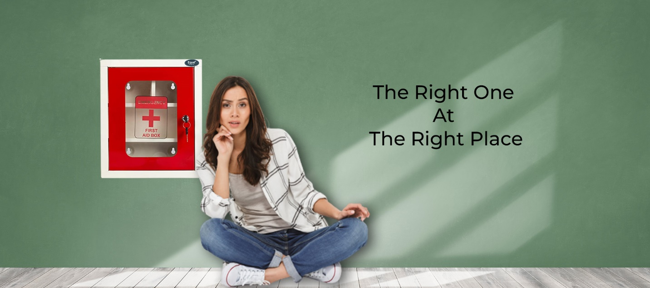

Let us talk about the importance of having a first aid box! Accidents are bound to happen at any given time, and being prepared can be the difference between life and death. That is why a first aid box is a must-have in any home, office, or vehicle.

**What are the benefits of a first aid box?**

A first aid box is essential because it can help you deal with minor injuries and even save someone's life in case of a medical emergency.

Here are some benefits of having a first aid box:

**a. Instant help**

Having a first aid box means you can respond quickly to any emergency. A first aid box will have all the essential medical supplies, and you will not have to run around looking for them.

**b. Can help save lives**

A first aid box can be the difference between life and death in critical situations. If someone has a severe injury or is choking, you can use the supplies in the first aid box to stabilize them and keep them alive until medical help arrives.

**c. Helps in reducing pain**

Minor injuries like cuts, burns, or sprains can be treated with the supplies in the first aid box. Applying a bandage or an ice pack can reduce pain and prevent further damage.

**How to choose the perfect first-aid box?**

Choosing the right first aid box can be overwhelming, but having one that meets your needs is essential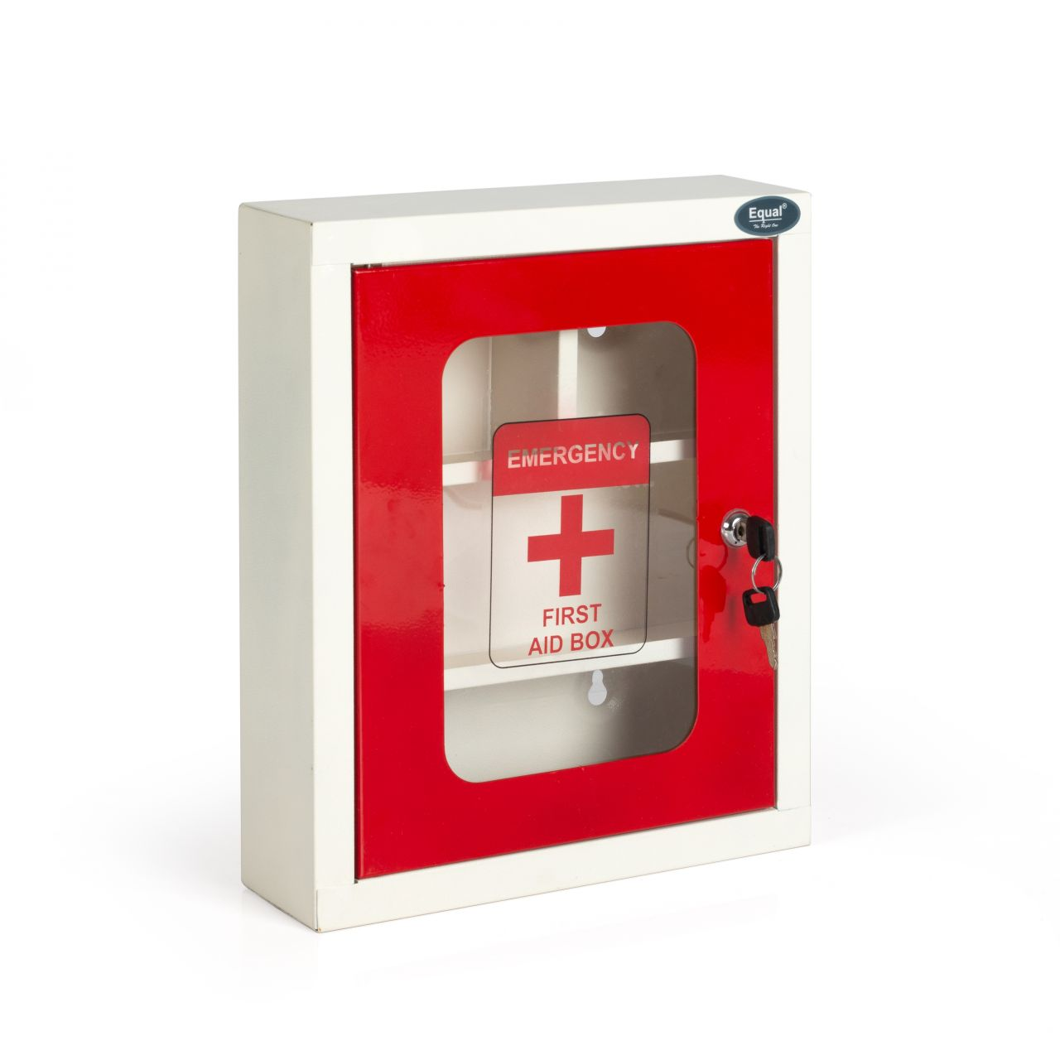

Details to choose the right first aid box:

**a. Size**

The Size of your first aid box should depend on the number of people it will serve. If it's for personal use, a small box will suffice. However, you may need a larger box with more supplies if it's for a group.

**b. The kind of supplies**

A good first aid box should have all the necessary supplies. It should contain band-aids, gauze, antiseptic wipes, adhesive tape, scissors, gloves, and a CPR mask, among other items.

**c. Ease of use**

The first aid box should be easily accessible in case of an emergency. It should be placed in a visible location and within reach.

**First aid box at Equal**

At equal, we have the best first aid box for your needs. This product is made of coated iron sheet metal which ensures a long and sturdy life. The color is red and white. The approximate weight is 1.5kg, and it comes with four shelves. What's even better is that it also comes with a 3-year warranty. So, go ahead and explore this [first aid box](https://www.equalequip.com/products/equal-first-aid-kit-boxmedical-boxfirst-aid-box-for-homeofficewall-mountable-with-lock) right away!

**Conclusion**

A first aid box is essential and should be a priority for everyone. Accidents can happen at any time, hence being prepared is important. We at Equal provide the best first aid box that caters to all your needs and requirements. Remember to choose a first aid box that meets your needs and has all the necessary supplies. Stay safe and be prepared!